Northeast Public Power Association (NEPPA) Committee Structure

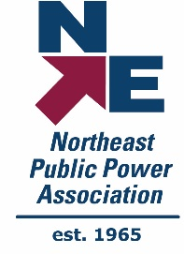
Advocacy & Reporting Committee
Conference Oversight & Planning Committee
Education Oversight Committee
Finance
Committee
Member Value Committee
Mutual Aid Committee
Energy Connect Conference Subcommittee
Safety Committee
Annual Conference Subcommittee
E&O Subcommittee
Lineworkers Rodeo Subcommittee
Engineering Subcommittee
Nominating Committee
NEPPA Members
Board of Directors
Executive Committee

